ENVISION ONE SOP

V2.0

Things you’ll need:

1. PPE
2. Resin filter
3. 16oz cup
4. Resin

Layout

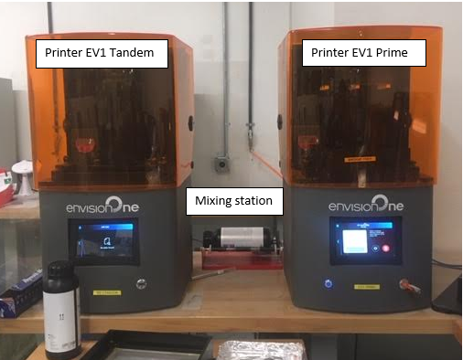

Training is required prior to operating Envision One printers. This guide is only for operators who have been trained.

Prior to first use, be sure to check resin. If necessary, filter and top prior to use. If you remove the resin tray, be sure to prime the O2 again before printing (*\*\*priming sequence is part of training**).* A full resin tray should look like this:

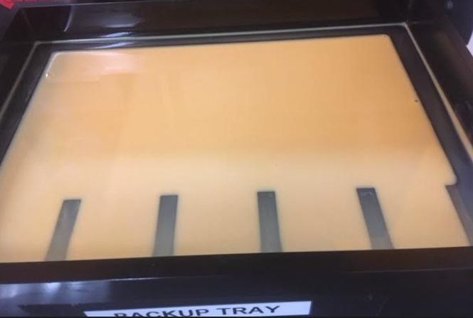

**DO NOT OVERFILL**. Resin must roll on mixing station for an hour.

Nesting

Create new project in envisionone app and be sure material is set to E cast.

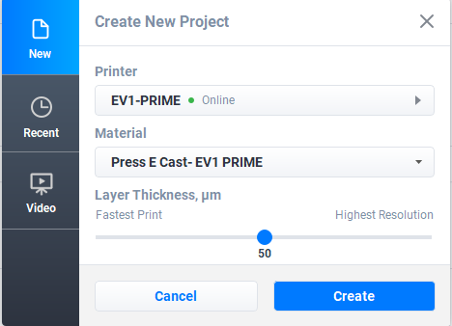

F7 all models prior to nesting. Center, flip 180, and add supports.

Be sure beam spacing is set to 3.9 prior to adding supports for E casts and 1.0-2.0 for regular models.

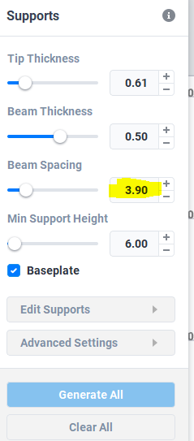

Complete one nesting at a time to be sure everything is correct. The resin is $695 per bottle. Rushing through details can cost a lot.

Verify proper print by viewing slices prior to printing. **This is part of training.**

Send job to printer after you change the name to our naming convention. **This is part of training**.

Save job after sent to printer in the envision folder with proper naming convention.

What not to do:

Do NOT try to nest more than one file at a time.

Do NOT forget to check resin for debris and level prior to printing.

Best practices

Nest one frame at a time.

Add supports to areas with known issues (origin points, pads, clasps).

Get someone to double check your work.

Don’t rush.

Spend time up front so you don’t have to do costly reprints later.